Franklin Colton Parry

CS 2600 Sec 001

Lab 7

12/12/13

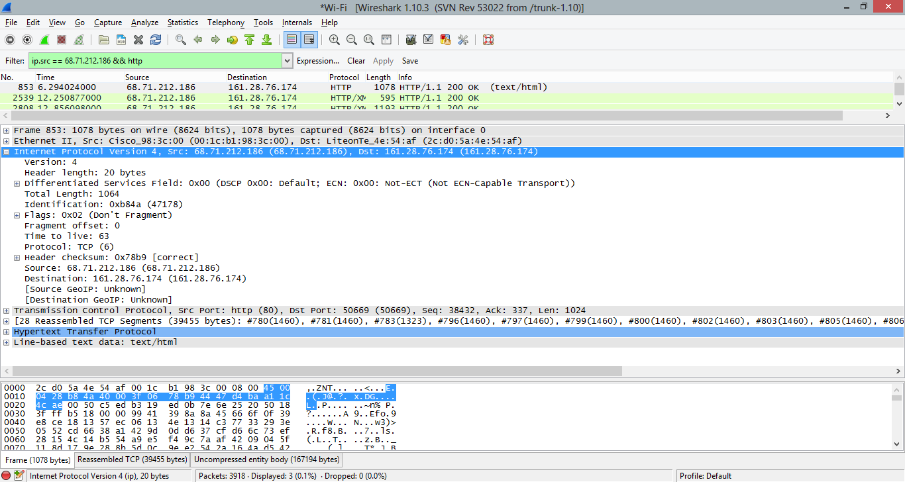

1. What is the IP header length in bytes? (Wireshark translates the value in the *Header length* (HLen) field to the actual number of bytes.) 20 bytes

2. What is the number actually contained in the *Header length* field? The number is 5.

3. What is the *Total Length* of the IP packet? 1064 Bytes Does this include the IP header? Yes. Does it include the Data-link layer (Ethernet or WiFi) frame header? No

4. What is the Time to Live value? 63 What does this represent? The number of network hops the packet can make. Can you make an “educated guess” as to how many routers this packet has crossed on its way to your computer? (Answering this requires a bit of intuition). I’d guess about 15.

5. What is the Transport protocol carried within this IP packet? TCP

6. Are there any options present at the end of the IP header? If so, what are they? None are available

7. Clear the HTTP filter so that you are once again displaying all of the captured packets. Try **Statistics | Packet Lengths… | Create Stat** again (without a filter). What are the predominant ranges of packet sizes? Speculate as to why this is the case. I’d speculate that the larger packets are IP packets and the smaller packets are for a different nature, probably a TCP packet.

